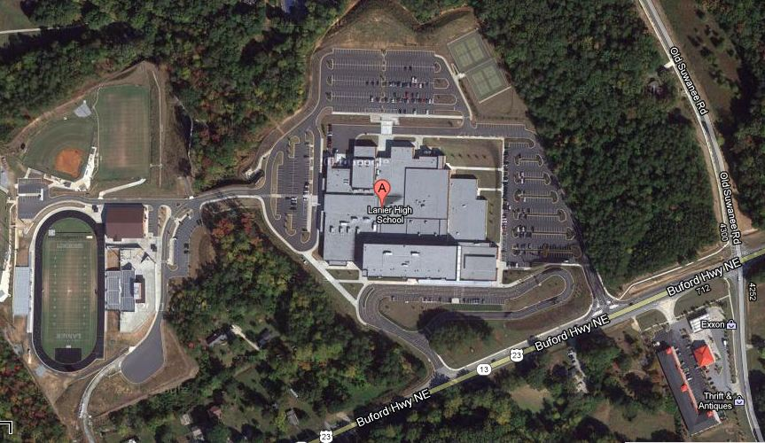

**All Patrons**

**Enter Here**

Buses Enter Here

Football Bus Parking.

Visitor Locker Room

**Reserved**

**Parking**

**\*3 VIP \***

**Officials**

**Parking**

**Visitor’s Gate**

**Home Gate**

**Field House**

**Reserved**

**Parking**

**Tractor**

**Trailer**

**Parking**

Band / Cheer Bus Parking

**Reserved**

**Parking**

**\*2 VIP \***

**General Parking**

**General**

**Parking**